Ballina Co. Tipperary

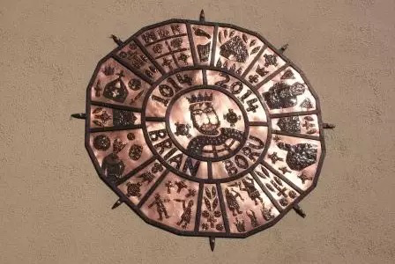
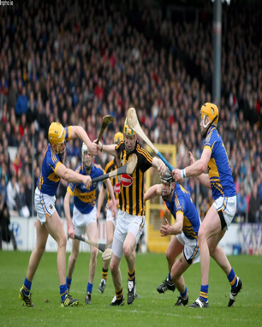
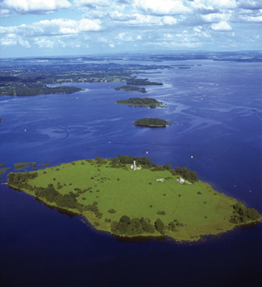
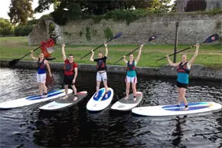
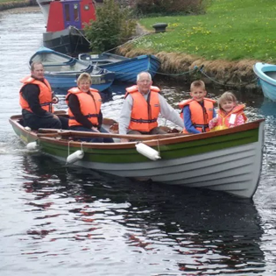
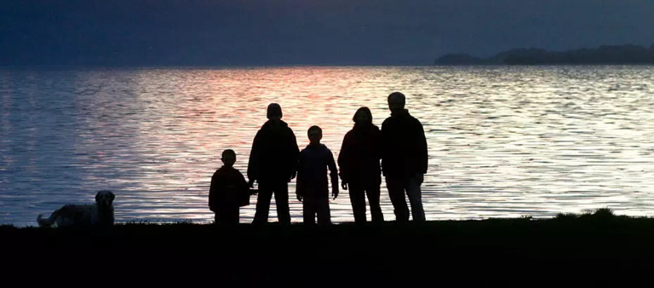
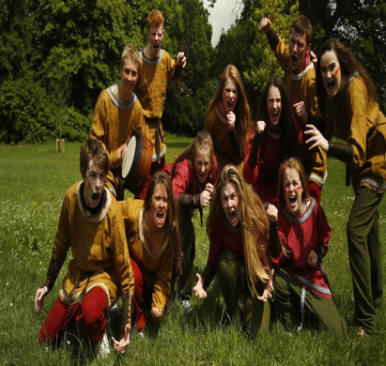
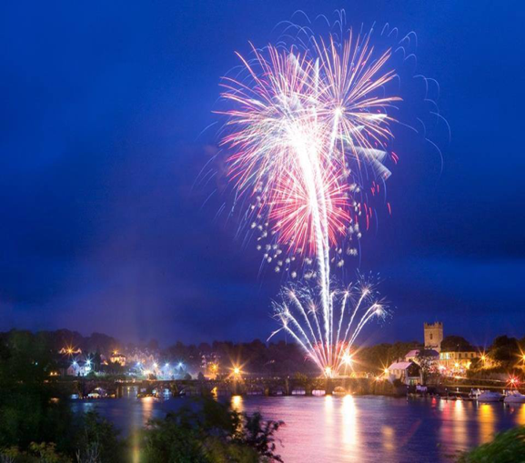
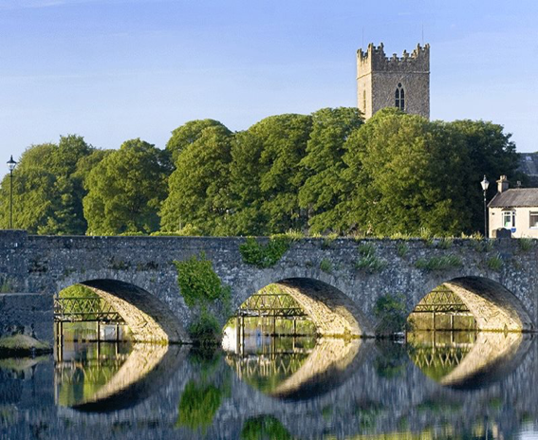
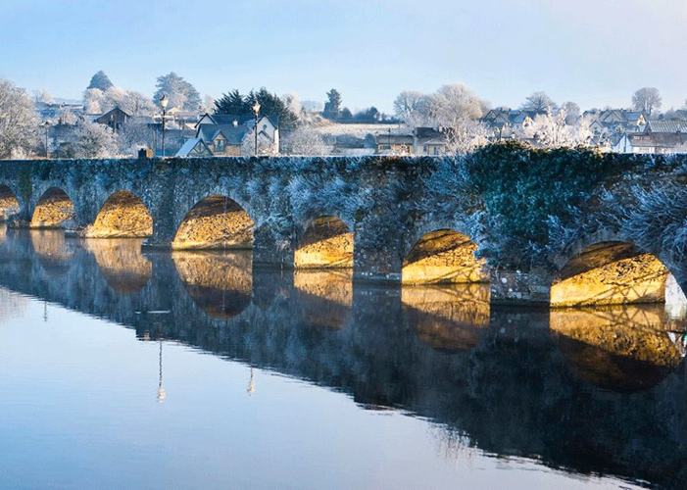
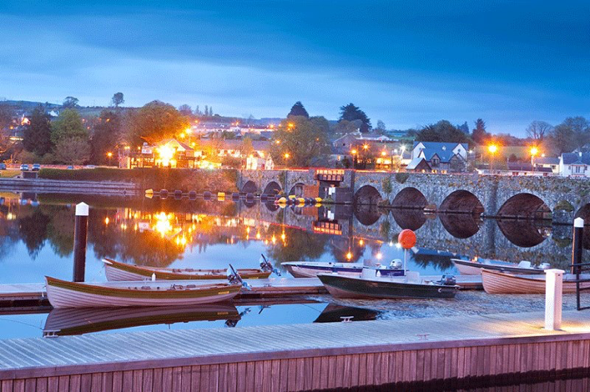
Twinning Project
The townland of Ballina is situated in North Tipperary on the shores of Lough Derg, one of the three lakes on Ireland’s largest river, the River Shannon. Ballina is a designated heritage town, in Irish called Béal an Átha meaning mouth of the ford, for centuries a major crossing point of the river with historical links to the famous King of Ireland Brian Boru and also Patrick Sarsfield.
Situated in a beautiful hinterland between the Arra mountains and the Clare Hills, Ballina has grown extensively in recent years, its population being one of the fastest growing in Ireland. Once largely rural and agricultural in nature the town now boasts a somewhat cosmopolitan flavour with many of its residents working in the nearby city of Limerick and particularly in one of Ireland's newest Universities – University of Limerick. There are strong linkages with its sister town of Killaloe in County Clare from which it is separated by a distinctive 13-arch bridge.
Ballina offers a welcome to newcomers and tourists alike and affords wonderful opportunities for fishing, boating, hill walking, swimming, cycling and water sports. The Gaelic Athletic Association has a long tradition in the town with a highly active club where one can experience the real spirit of the world’s fastest field game –hurling, in a county famed for its passion and success in the national game. The area is renowned for the quality of its cuisine and boasts of fine accommodation and restaurants. Ballina also hosts many successful festivals which attract huge numbers to celebrate the rich cultural heritage, to experience the delights of the wide range of water activities or to enjoy culinary events including garden parties, BBQ demonstrations and “A Taste of Lough Derg” – a series of food events held throughout the months of June, July, August and September to showcase some of the food being produced in the Lough Derg Lakelands region. From chocolate making to cheese tastings, the events are enjoyable, educational and open to everyone.
A further attraction is the number of venues providing live entertainment. Traditional Irish Music and dance are known today throughout the world. The area provides a range of traditional Irish Music sessions performed by a wide variety of gifted musicians, with some wonderful Irish dancing on display. Other live music sessions are also available to suit all tastes.
If you come to Ballina you are assured of the famed Irish Welcome, “Céad Míle Fáilte” – A hundred thousand welcomes.

