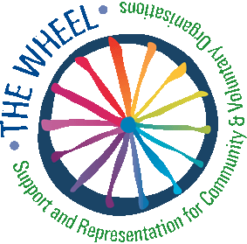

Partner Search Form

Identification of the applicant
Name of the organisation | WALK
Registered address (street, city, country) | 1 Long Mile Road, Walkinstown, Dublin 12
Telephone / Fax | 4650388/4607899
Website of the organisation | www.walk.ie
Name of the contact person | Austin O'Sullivan
Email/Telephone of the contact person | austin@walk.ie
Short overview of the organisation (key activities, experience) | WALK were founded in 1967 to provide community based supports to adults with intellectual disabilities. Today we use our expertise to create social capital and to support not only people with disabilities, but other groups from marginalized communities.  We offer direct lifestyle choice, education, training, housing and employment supports to over 600 people in Ireland
Description of the project
Strand, Measure in the framework of “Europe for Citizens” Programme | Strand: Democratic engagement and civic participation.  2.3 Civil Society Projects
Timetable of the project
Short description of the project, including its aims | Create a network of organisations promoting PEER Mentor Volunteering as a route to greater inclusion in civic society for those of fewer opportunities.  PEER Mentors are trained volunteers who give their time to support others of similar age, who are disadvantaged or excluded, to access and participate equally in civic society.
Role of the partner organisation in the project | Identify target groups in their country. Adapt WALK PEER Model to their groups.  Accredit PEER training for volunteers in their country. Roll out PEER Model in their region.
Comments from the applicant

The Wheel is the national contact point for the Europe for Citizens Programme in Ireland. The information service is funded by the Department of An Taoiseach and the Education, Audiovisual and Culture Executive Agency (EACEA).

